N. Bosler, T. Florencki, O. Omusi, M. Wohlwend

Team IC-U
Low Level Design

EE Senior Design
2/18/2010

Table of Contents
1. Introduction 2
2. Problem Statement and Proposed Solution 2
3. System Description and Block Diagram 3
4. System Requirements 4
1) Overall System 4

2) Subsystem and Interface Requirements 5

3) Future Enhancement Requirements 7

5. Low Level Design 7
6. Bill of Materials 12
7. Conclusions 13

- Introduction
The goal of senior design is to give electrical engineers the practical and ethical knowledge required to actually implement engineering concepts into useful applications. Team IC-U hopes to combine the knowledge gained from the EE curriculum over the last four years with the concepts of good design to develop a product to solve a problem and meet all the design requirements as contained in this document.
- Problem Statement and Proposed Solution
Security systems use many different inputs to alert the owners, but can do very little as far as actively deterring intruders and determining their identities. Also, many systems use low quality video cameras to capture movement but cannot capture descriptive features of the intruder. This project seeks to create a system that can both act as a physical deterrent and capture hi-resolution images of the intruder.

The proposed solution to this problem involves integration of a ‘seeker’ camera and a combination gun/high-resolution camera attached to two servo motors for control. The incoming video feed from the seeker camera (which remains stationary) will be analyzed for motion within the frame. The location of motion from the seeker cam will then translate to movement of the gun and high-resolution camera through the use of two servo motors. The system can then either fire the gun and/or capture images with the high-resolution camera. An embedded ARM computer will be used to handle communication between the various system elements.

- System Description and Block Diagram
Red
Green
CO₂
Paintballs
Compact Flash
6V
9V
5V
5V
5V
1 I/O
USB
Power
SSH
Physical
On/Off
Switches
Ethernet
1 I/O
2 I/O
2 I/O
2 I/O
ARM
USB Hub
Seeker
Cam
High-res Cam
Image
Storage
User
Control
LED
Indicators
Power
Board
Servos
Gun Electronics
Gun
Mount

User Control
The user control portion of this system will allow the user to control the mode of operation of the deterrence aspect. The user will be able to turn the system on and off and be able to toggle the system’s use of the gun (on or off) based on the desired application of the system. To do this, easily-accessible switches will be connected to input terminals on the ARM. The user will also be able to connect to the ARM via SSH allowing for control commands to be sent remotely.

ARM Computer
The ARM Computer is the main processing and control unit of the project. The ARM will take the video from the ‘seeker’ camera, and depending on the state of the User Control switches and control commands, process this video to determine if movement occurred. If movement occurs it sends a location signal to the servos and a fire signal to the paintball gun and high-res camera.

Paintball Gun
The paintball gun is the deterrence portion of the system. It is controlled by a dedicated electronic board which is easily controlled through the I/O pins on the ARM board. Supplies for the gun (paintballs and C0₂) will be manually refilled, with the tank located off the gun to reduce weight.

High-Resolution Camera
The high-resolution camera will be mounted along with the paintball gun and will be used to capture images when motion is detected. This allows for the identification portion of the system. The camera will be triggered using an I/O pin on the ARM board.

‘Seeker’ Camera
The ‘seeker’ camera will be a low-resolution web camera that will be used for the purpose of analyzing movement. This will be connected via USB.

Digital Servos
The two servo motors move quickly and accurately to aim the paintball gun and the high resolution camera at the target detected by the seeker camera. These will be controlled via two I/O pins on the ARM board.

Power Board
The power board will source the power for all the elements except the ARM board which will have its own separate power to protect it from the current draw of the servos. It will also contain circuitry to buffer the I/O pins and further protect the ARM.

Gun Mounting and System Case
The mount for the gun and high-res camera will support their combined weight as well as allow for the two axis rotation of the servos. The case will also allow user access to the necessary communication ports and provide LED indicator lights.
- System Requirements
- Overall System
This system is required to do two major things for successful operation. It must accurately detect and identify intruders to provide evidence to law enforcement by taking and storing photos of them. Also, it must deter the intruder from approaching the system through the use of an electronic paintball gun. These settings - whether to detect and/or deter - must be controllable by the user from a safe and remote location so that the system can be enabled or disabled without unintentional harm. Big visible LEDs next to the gun will also be lit to indicate whether the system is on, detecting motion or armed to fire.

The system will have a detection threshold that will differentiate between what might be small environmental changes such as a leaf blowing in the wind and actual human-size intruders. The system will also prioritize whenever it detects multiple targets, always choosing to detect or deter the bigger moving object. This will be implemented in the algorithm running on the system along with targeting tweaks that will compensate for the drop experienced by the fired paintballs under the force of gravity.
The system needs to be contained in one simple box as small as possible. The small footprint will allow for the system to be mounted in a way that makes it less noticeable for possible intruders. Components will be as small as is feasible to facilitate this. Also, the turret mount for the gun needs to be strong enough to support the weight of the gun but not too heavy so that it can be aimed quickly.

The power requirements for this system are complex. While it might be useful to have this system run on a battery, the power draw is too high to allow for long periods of operation, so our system will draw its power from a standard AC 120V outlet and convert that to a range of voltages for our ARM microcomputer, servo actuators, cameras and the paintball gun.
- Subsystem and Interface Requirements
User Control
The switches need to allow for a connection between the input voltage and the input pins that control the on and off operation of the paintball gun and the high-resolution camera. Flipping the switch on or off will turn the paintball gun on and off. The other switch will control the on/off of the entire system. Users will be able to send commands to the system to turn on and off any subsystem using SSH through the ethernet connection on the board. The SSH connection will also allow for remote connection to the board. The User Control must protect the user from unintentional firings.

ARM Computer
The ARM computer needs to be able to process the video input from the ‘seeker’ cam. It must be fast enough to process this and send ‘fire’ signals out before the target has moved. The ARM must also handle all the communication between devices. Most of the communication will be handled with USB interfaces, specifically for the ‘seeker’ camera. The other devices will be controlled by the digital input/output (DIO) pins on the ARM’s board. Also, the ARM Computer will need to be configured to properly output the servo control signals.

Paintball Gun
The paintball gun needs to have an electrical firing mechanism so that it can be easily triggered by setting a digital output pin. It will also need to be supplied with the necessary CO2 and paintballs.

Gun Mounting and System Case
The gun mount needs to be strong, light in weight, and allow for pivoted movement in the horizontal and vertical planes. It will connect with the servos through a 2:1 gear ratio that will allow for more torque although simultaneously less speed and range of motion. Because the system is more dependent on torque than speed in targeting and tracking objects, this should not be a problem if sufficiently fast servos are used. The mount must also be stable enough to handle the small amount of recoil that comes from the gun. The case must be strong enough to support the gun mount and sturdy enough to prevent it from moving. It must also protect the ARM from the weather, and give the user easily accessible interfaces.

High-Resolution Camera
The high-resolution camera should have a minimum resolution of 10 mega pixels and a minimum optical zoom of 3x in order to provide a detailed image of the moving object. The camera must have the capability to be externally triggered from the ARM and have SD card storage capacity of at least 2GB so that numerous pictures can be taken.

‘Seeker’ Camera
The seeker camera needs to be a low resolution (preferably VGA) so that it will not require as much processing power to implement the motion-sensing algorithm. In addition, it should be small so that it will not be in the way of other components. It must support UVC drivers to allow for communication with the Linux operating system.

USB Hub
A USB hub is required to expand the number of USB ports available for use within the system and also to supply power to the devices connected to it so as not to strain the power draw of the ARM board. In addition to this, it will allow for easier external accessibility so that the user may connect a keyboard for development purposes.

Digital Servos
The servos require 4.8-6V to operate and will have their own power source independent of the ARM. This voltage determines the amount of torque that the motors generate which must be enough to move the paintball gun, the high-res camera and their mount. The servos are digital precision servos that are controlled by pulse width control which the ARM orchestrates. These servos will move in horizontal and vertical 90 degree angles simultaneously. The servos will be powered from the separate power board, while the control signal will come from the I/O on the ARM. As a safety precaution against potential feedback from the servos, a buffer will be added in the control signal line to protect the ARM.

LED Indicators
It is critical that the user and passers-by be able to tell what state the gun is in so big bright LEDs are necessary - green and red. The green LED will light up when the system is turned on and will flash while motion is detected. The red LED will light up when the system is armed to fire and will flash while firing.

Power Board
A PCB will be used to supply power to the different components of the system. An AC/DC converter will be used to convert a 120 VAC input. DC/DC regulators wil be used to convert the output of the AC/DC converter to the three voltages needed to run the system. 9V is needed for the gun, 6V is needed for each servo, and 5V is necessary for the USB hub. The peak currents required by the gun, servo motors, and USB hub are 0.5 A, 4 A, and 0.5 A, respectively.

- Future Enhancement Requirements
Audio Deterrence Audio Deterrence
In the interest of improved deterrence of intruders, vocal deterrence may be included. This will be in the form of audio recordings that will play whenever an intruder is detected, warning the individual that they are entering a restricted area and warn the intruder that he/she may be fired upon. If the system is in attack mode, then this system will also taunt the intruder while he is being physically deterred.

Implementing this concept will require audio speakers. However, the embedded ARM chosen for this task does not have an audio output port so USB speakers will need to be used.

Infrared Camera
An infrared camera will allow for better detection of intruders under all conditions. Adding a camera like this to the system would not be challenging, but it would greatly increase the overall system cost.

Web Interface
A robust web interface would be extremely useful in this project and would allow the current image on the camera to be displayed. It would also allow for the user to control the system from the web and many different portable devices. Unfortunately, it is likely that our current board does not have the processing power to make this possible.
- Low Level Design
User Control
There will be two switches externally available to the user. One switch will control the on/off status of the system. The second switch will toggle the firing of the paintball gun during normal operation. Each switch will be a three-way switch and will connect an input of the ARM to either GND or +5V so that the input to the ARM is never left floating.

ARM Computer
The arm computer is from embedded arm and is the TS-7300 model. This board contains a 200MHz ARM9 CPU with 32MB of SDRAM. This board was chosen because of its on board VGA output which allowed us to directly interface without having to use a computer. The added advantage of the ARM is functional USB and ethernet ports which allow the use of existing hardware and protocols. The board runs off of a 5V regulated supply that will be isolated from the rest of the system to avoid system crashes due to large current draws from the servos. The code that controls the operation will be run on this system.

Software
The control code for the system is relatively straight forward as can be seen in this flow chart:
Process Video
Update Servo
Servo Control
Fire is high
Fire Gun
Switch on
Target Algorithm

The challenge of this project is to implement this code in the specialized Debian Linux environment. In order to facilitate this, the original motion detection code which is in python will be rewritten to C/C++. This will allow for the code to interface with the on board DIO as well as the Open CV library. The Open CV library contains the necessary functions to do the image processing and capture.

From this large flow chart each sub section of code is further explained. This flow chart is for the video processing subsection:
Else
Capture frame
Add to Running Average
Calculate Movement
If diff = 0
Capture frame to determine size
Smooth
Initialize difference
Convert Scale of moving average
Subtract current frame
Convert to B/W
Get Blobs

The algorithm employed here compares the current frame to the running average of previous images. This is a more robust way to detect difference from frame to frame the just the changes between frames. Motion is detected by subtracting the current frame from the average and then grouping those detections into an X, Y array.

The target algorithm:
Determine Area
Compare to saved square
Update Servo
All Squares Drawn
X, Y Array of Detected Movement
Draw Square
Is square >
Threshold
Determine Center of Square
If > Save

This section of code is tasked with finding what movement should be shot at. To do this, a square is drawn around the blobs generated in the video processing section and then the largest of these become the target area. The center of this square is output as an X, Y coordinate.

Update servo:
X, Y coordinates of center
Convert to theta and phi
Convert to Pulses
To servo control

This section simply takes the X, Y coordinate output by the target algorithm and converts it to the necessary pulses to communicate with the servo. This will simply be a single variable that contains with the width of the pulse in milliseconds.

The servo control:
The servo control will be completely done through interrupts because the servos must receive a constant signal at regular intervals (20 millisecond period). Four interrupts will be needed, two for each direction. One will switch the output high every 20 milliseconds, and another will trigger either the default 1.5 milliseconds after the high trigger, or the output of the update servo.

Paintball Gun
The paintball gun (make: Spyder, model: Xtra) will be triggered by a DIO pin of the ARM, shown in the figure below. The DIO pin will be directly connected to the gate of a MOSFET, with a VGS on of 3.3 V. This is the value of the voltage of a high DIO pin. When the pin is at a high level, the drain-source conductance of the MOSFET (M1) will become high. This will turn on M2, which is located in the circuitry inherent to the gun. When this happens, the electronic trigger (make: e-marker) will cause the gun to fire. The 5 V will be taken from the output of the 5V voltage regulator.
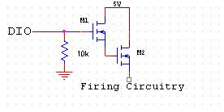
A DIO pin will also be used to turn the gun on and off. This feature allows for additional safety. CMOS circuitry will be used to implement this. The output of the CMOS circuit will be tied to the pin of the gun PCB that controls the state (on or off) of the gun. When the DIO pin is low, the gun will be on, and when the pin is high, the gun will be off. The 9 V will be taken from the output of the 9V voltage regulator. See the figure below.
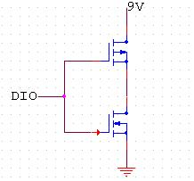

To test this part of the system, simple code will be written to toggle DIO back and forth from high to low. This will show that the DIO pin is capable of firing the gun.
Gun Mounting and System Case

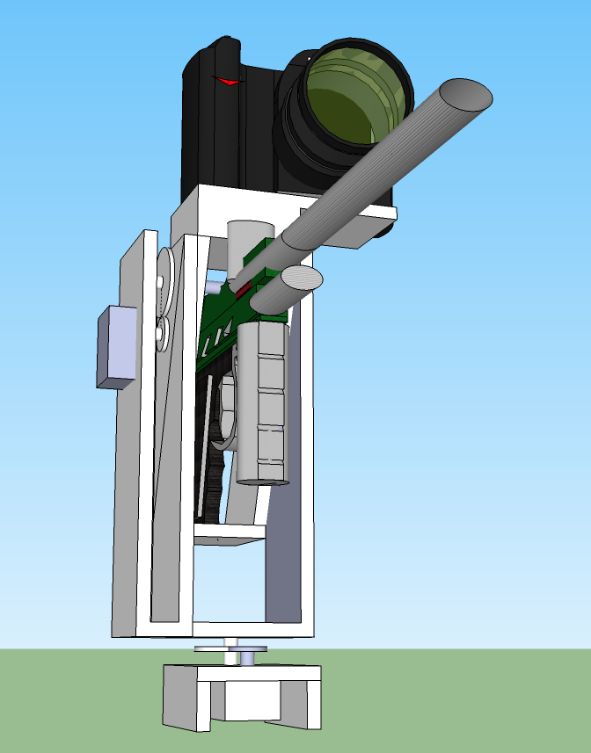
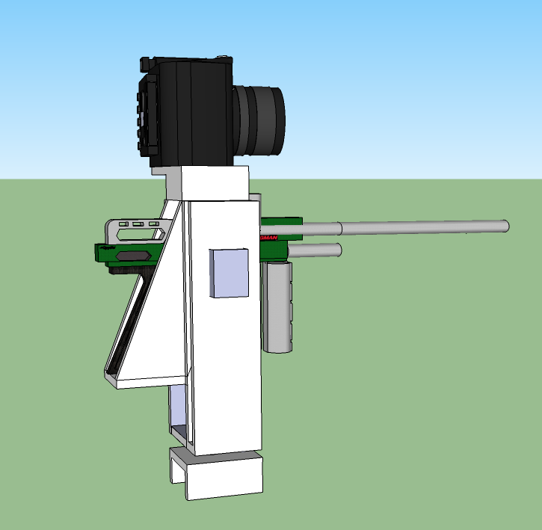

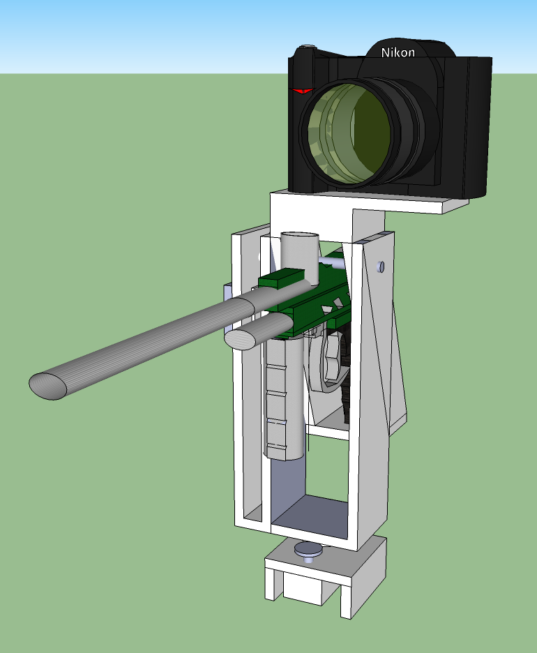
Servos with gears

The main challenge of the mounting system is to provide a solid mount for the gun and high-resolution camera and places the rotating points near the radial center of gravity. Doing this decreases the moment of inertia and thereby decreases the load on the servo motors. As seen in the picture, the gun attaches to the mount at the base and sides of the handle for stability. The high-resolution camera mounts above the gun. The base below the servo (which will be stationary) will be expanded to mount the seeker cam.

The system case will contain the ARM board and power board. In addition, it will have external accessibility to power (to plug into an outlet), ethernet, and USB ports (for development) as well as signals to the gun/camera. Inside of the case, the power will split to both the power board and to the ARM. Signals from the ARM will be routed up to the gun and camera through the case.

High-Resolution Camera
The requirements for the high-resolution camera, in particular the ability to be triggered via an external signal, leads to more professional-grade cameras which tend to have this feature. Because of this, cameras that have this feature are considerably more expensive than our budget allows for.

As a proof of concept, our system will include a Nikon D2H camera, an older version of the camera but that still includes the capability to trigger externally. This camera has under 10 mega pixels of resolution, but the higher optical zoom and higher-quality CCDs make up for this. In addition, the camera uses a Compact Flash image storage instead of an SD card listed in our requirements. The purpose of this requirement is to allow easy transfer onto a computer, which can be done with an adapter for the Compact Flash card.

To externally trigger this camera, a cable is needed which terminates in a 3.5mm mono jack. When the two ends are shorted together, the camera takes a picture. This will be controlled by the ARM board through the use of a MOSFET. When the output pin from the ARM goes high, the MOSFET will close the circuit to fire the camera.

‘Seeker’ Camera
Currently, the ‘seeker’ camera will be a USB-driven device. The web camera must be UVC (USB Video Class) compliant, allowing it work with the Linux UVC driver. This driver will be added to the ARM. The output of the driver will be handled by the system code, which is discussed in a later subsystem. A list of UVC compliant cameras was found on the Internet. Logitech’s C250 was determined to be the best option because of cost and the desired VGA quality output of the product.

To test this aspect of the system, a few lines will be added to the code to make one of the LEDs on the ARM turn on whenever motion is detected. This is a simple way to show that the ARM is processing the web camera input.

USB Hub
A 7 port USB hub will be used to provide additional USB input capability. It will be powered by a separate source, which is discussed later. This reduces the stress felt by the ARM.

Digital Servos
The gun weighs 4.4lbs (70.4 oz) and the mount should be relatively light in weight. The servos must be capable of not only holding the weight of the gun and mount but also of accelerating the system from a stationary point to aim the gun. These require holding torque and moving torque respectively. Hitec HS-5645MG Digital Torque servos that generate 168 oz-in (10.5 lb-in) maximum/stall torque and 0.18s/60° max speed (unloaded) will be used to aim the gun. To ensure that there is enough torque, the mount to servo link will be geared 2:1 for twice the torque and half the speed. Fortunately, half the speed will not seriously affect our performance especially when the gun is tracking a moving object since it will only have to continuously turn through small angles.

The servo can run at anywhere from 4.8-6V with optimal operation at 6V. The current draw on these servos when unloaded is 500mA but under heavy loads the current draw is up to 2A with some observed deviation.

The servos are digital servos because these have up to ten times the response time of the analog versions and are necessary since response time is a critical factor in evaluating the performance of the system. But the fact that they are digital also means that they have a higher current draw than the corresponding analog servos.

The servos are controlled by pulse width modulation (PWM) at 3-5V, 50Hz. The control signals will be sent over the DIO pins on the ARM with a pulled-down MOSFET switch interfacing between the two to protect the ARM from any unexpected feedback or power spikes that might come from the servos.

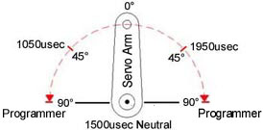

Before actually using the servos with the rest of the system, it will be necessary to measure the maximum current draw that the servos pull. To do this, the servo must be stalled while the current is measured i.e. the servo horn must be loaded with the maximum amount of weight that it can possibly carry. At this point, it will be drawing the maximum amount of current. This figure will be necessary to know so that the regulator supplying the servo can meet this amount.

LED Indicators
The LEDs that will be used will be for the indicator on the system case will be huge 10mm through hole LEDs. The green LED is rated at 3.0 - 3.4V DC forward voltage, 80mA forward current, 30 degree viewing angle, and 16,000-22,000 MCD output. The red LED is rated at 2.1 - 2.3V DC forward voltage, 80mA forward current, 30 degree viewing angle, and 10,000-12,000 MCD output. The green LED outputs 515-520nm in the green spectrum and the red LED out puts 625-630nm in the red spectrum.

The DIO pins of the ARM will connect directly to these LEDs. The LEDs will light up when the pins are set low (active-low LED drive connection) so that there is never any current draw from the ARM. Because the microcontroller logic is at 3.3V, the necessary forward voltages through the LEDs will be obtained by connecting resistors in series with them.

It will be necessary to test that the LEDs can be lit and be set to flash on and off through setting pins high and low on the embedded ARM through software compiled and running on the ARM. This will be one step away from actually sending commands through the main code indicating if the system is on, motion is detected and the gun is armed.

Power Board

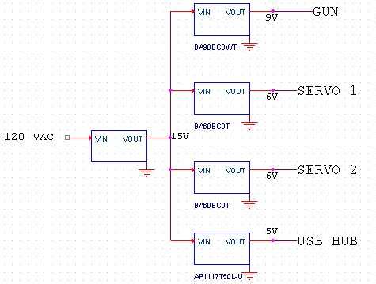
The input to the power board will be an AC/DC converter coming from a 120V AC standard outlet to a 15V DC. The board itself serves two functions: to provide the necessary voltages (and enough current) for each item in the system to function correctly and to provide buffers between the ARM I/O and what they communicate with. Providing the necessary voltages will be accomplished by using separate regulators to step down to 9V, 6V, and 5V. The power outputs to the gun and USB hub will use cylindrical type power connectors. Buffers for LED indicators, external user control switches, servo control signals, and gun signals will be realized by using MOSFETs located on this board.

Testing of the power board will simply involve measuring the voltage at each output to ensure that the circuit functions correctly.

Overall System Tests

Power Test: For this test, the complete system will be powered on and movement commands will be sent to the servos to move the gun while current and voltage measurements are taken on different subsystems. This test will ensure that the system has enough power to properly run all the different subsystems without affecting performance.

Tracking Test: This test will measure the speed and accuracy of the system when tracking a moving object. It will be performed in two phases.
In phase 1, the gun will not be attached to the mount while the system is running. Instead, a laser pointer will be used. This will determine the ARM's video processing speed with negligible response time on the unloaded servos. The object being tracked will be a white board on wheels that will be moved across the camera's field of view at varying speeds. Success will be measured by the laser pointer's ability to fall on the moving white board at the different moving speeds.
Phase 2 will be the same test but with the servos loaded with the gun instead of a laser pointer. This will measure the overall speed of the system (taking into account software, electrical and mechanical response times).

Firing Test: This test will measure the trajectory of the fired paintballs so that tweaks may be made in the algorithm to compensate for the force of gravity on them. It is recommended that a white board on wheels pushed by someone behind the board be used as the tracking object as opposed to just an actual person in order to minimize injury. Several reiterations will be performed from different angles (10º intervals) to ensure maximum accuracy. The downside to this test is that it will have to assume that the object being tracked is always at a certain distance (or distance range) away from the camera.

- Bill of Materials
Item | Qty. | Cost | Location
TS-7300 High-Security Linux FPGA Embedded Computer | 1 | $219 | www.embeddedarm.com
UFD CO2 HPA Paintball Thick Coiled Remote QD ON/OFF | 1 | $20.70 | www.amazon.com
USB Highspeed 7 Port Hub w/ AC Adapter | 1 | $7.19 | www.amazon.com
Rocketfish RF-BPRAC3 Universal Laptop AC Adapter | 1 | $14.99 | www.amazon.com
Logitech C250 Webcamera | 1 | $25.60 | www.amazon.com
HS-5645MG Digital Torque | 2 | $56.99 | www.servocity.com
22-toot RSA32-2HS-22 Servo mount gear | 2 | $4.32 | www.servocity.com
3/8” (.375”) 3468H Set Screw Hub | 2 | $4.99 | www.servocity.com
44 tooth 3/8” RHA32-26-44 Hub Gear | 2 | $4.44 | www.servocity.com
5.00” SS375-5.00 3/8” Precision Shafting | 1 | $7.48 | www.servocity.com
1.00” SS375-1.00 3/8” Precision Shafting | 1 | $4.80 | www.servocity.com
9v Regulator, BA90BC0WT | 1 |  | www.digikey.com
6v Regulator, BA60BCT0T | 2 |  | www.digikey.com
5v Regulator, AP1117T50L-U | 1 |  | www.digikey.com
AC/DC converter, SA052A5W | 1
MOSFET |  |  | www.digikey.com
22 AWG Female to Female DB9 Cable | 1 | $25.00 | www.customcableconnection.com
Custom PCB | 1
Spyder Extra Electronic Paintball Gun | 1 | $0
Nikon D2H SLR Camera | 1 | $0
10mm Super Bright LED - green | 1 | $1.50 | www.sparkfun.com
10mm Super Bright LED - red | 1 | $1.50 | www.sparkfun.com

- Conclusions

Through the use of existing technologies Team IC-U hopes to integrate two useful security features into one system. Integrating the paintball gun allows a security system to fight back against intruders and actively deter crimes from occurring. Using the high resolution camera to identify intruders, the system also helps in the prosecution of the intruder. The system increases safety for its users and their household or business.
The key challenges of developing this system are the motion sensing algorithm and communication between each system. This all relies on successful implementation of the ARM computer from a software and hardware standpoint. The software needs to be able to generate all the necessary signals for communication and process the video and picture storage.

References:
http://www.embeddedarm.com/products/board-detail.php?product=TS-7300
http://www.servocity.com/
http://www.pyroelectro.com/tutorials/servo_motor/theory.html
http://www.paintballsentry.com/Products.htm
http://appdelegateinc.com/blog/2010/08/02/motion-tracking-with-a-webcam/
http://www.codeproject.com/KB/audio-video/Motion_Detection.aspx
http://www.ideasonboard.org/uvc/

