8 Appendices

Appendix A: Installation Guide
BusTracker
Department of Electrical Engineering - Senior Design
University of Notre Dame

Installation Guide
Table of Contents
Overview of Parts and Connections 1
Installation of BusTracker 3
Installation on Gillig Bus (Older Bus) 3
Installation on New Flyer Bus (Newer Bus) 4
Setup of BusTracker 6
Verify Operation of BusTracker 6
Troubleshooting 7
Troubleshooting BusTracker Box 7
Troubleshooting BusTracker App 7
Customer Support 7

Overview of Parts and Connections
The major components of the BusTracker system is shown in Figure 1 below.
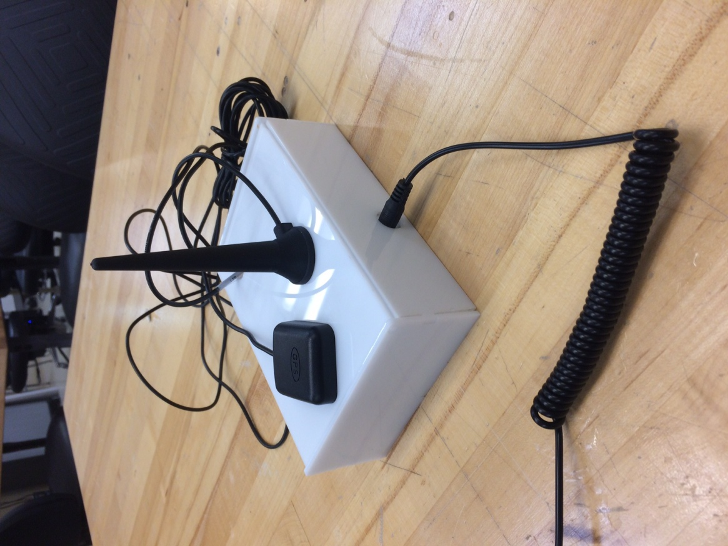
Power Connection
GPS Antenna
Cellular Antenna
Figure 1. Major BusTracker Components.
The inside of the BusTracker box is shown in Figure 2 below with the Indicator LED highlighted. The driver should never need to open the BusTracker box except for troubleshooting. The BusTracker box should not be opened while the bus is in operation by the driver.
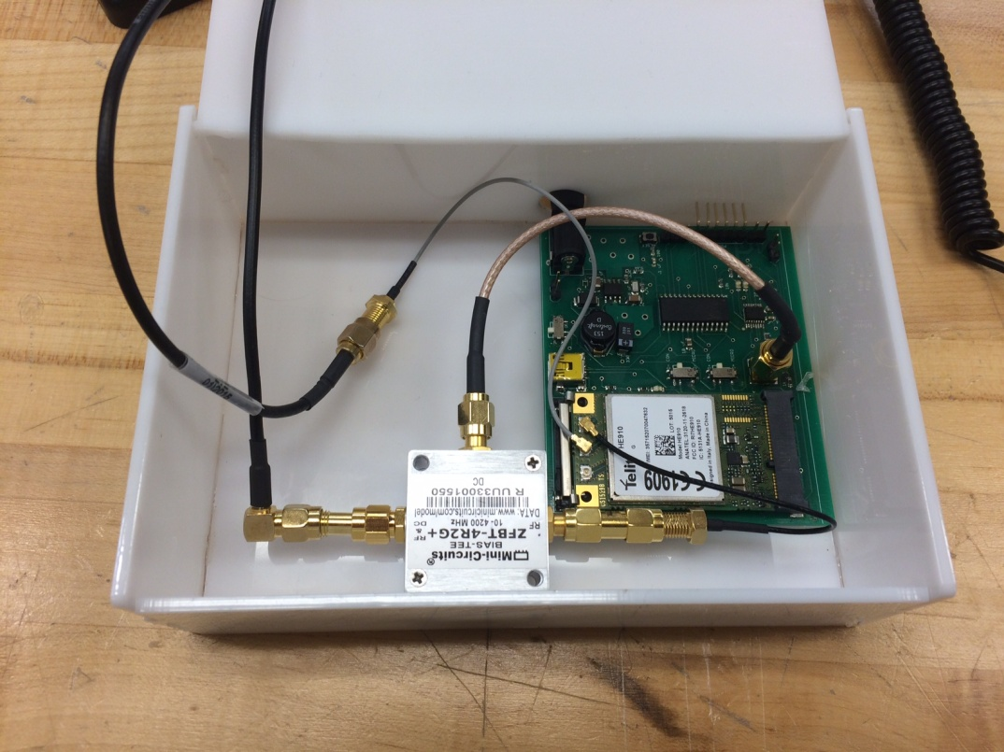
Figure 2. Inside of BusTracker Box, LED circled

Installation of BusTracker
The BusTracker is currently developed specifically for the South Bend Transpo buses (expansion beyond Transpo is possible but not currently implemented). There are currently two different bus models driving Transpo bus routes - the 2004 Gillig and the 2014 New Flyer.. Installation and placement of the BusTracker differs slightly depending on the model. Installation on a Transpo bus requires a slightly different power connector since 12V cigarette lighter car jacks are not available (utilized during personal vehicle demonstration). One end of the power cable for the bus should have a 2.1mm barrel jack connector. The other end of the cable will be stripped so that it can be tapped to a 12V line connection on the bus. The bus, regardless of model, should not be on during installation.

Installation on Gillig Bus (Older Bus)
On the Gillig model, the BusTracker will be mounted on top of the front dashboard next to the Motorola radio box. Figure 2 below shows the placement location of the BusTracker with a red circle.
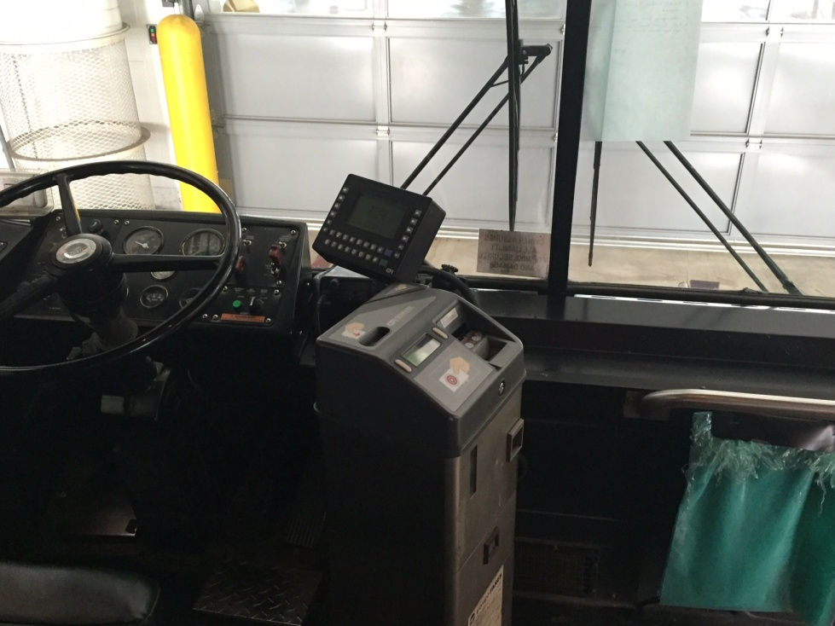
Figure 2. BusTracker location on Gillig
The power cable for the BusTracker should follow the same path as the Motorola radio box as shown in Figure 3 below.
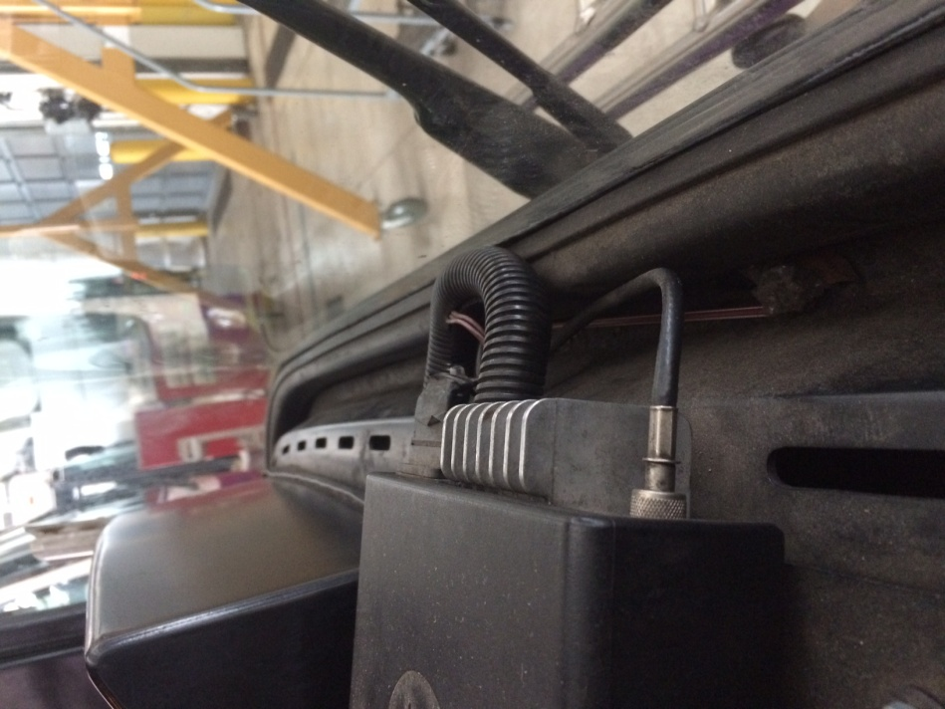
Figure 3. Power line connection to follow
The other end of the power cable should tap into one of the 12V lines behind left side panel of the driver's seat. The GPS antenna of the BusTracker should be affixed nearby on the dashboard without any objects blocking the antenna to the window.

Installation on New Flyer Bus (Newer Bus)
On the New Flyer model, the BusTracker will be mounted in the top right corner of the bus as seen from the driver's point of view. The BusTracker cannot be placed on the dashboard as on the Gillig bus because there are no 12V line connections nearby to tap power from. The GPS antenna will be affixed nearby along the top panel so that it will not interfere with the driver's line of sight. The mounting location for the BusTracker is shown in Figure 4 below.
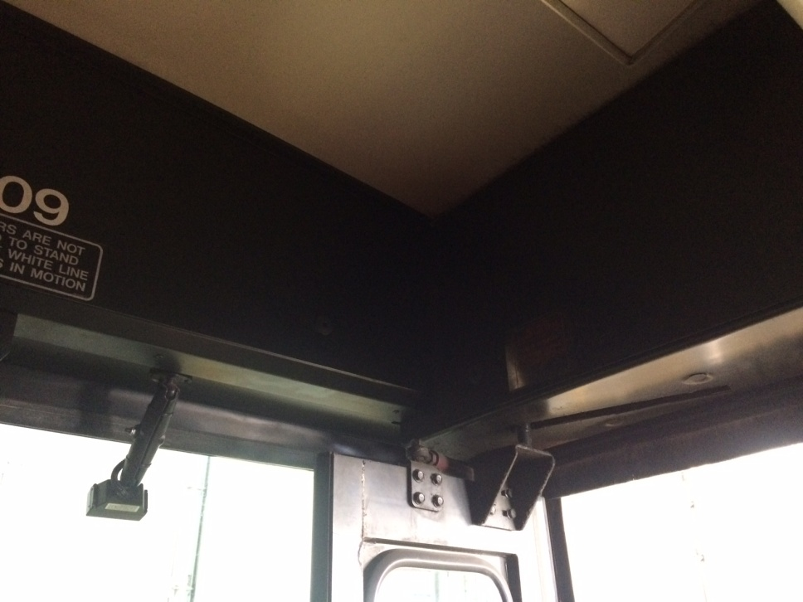
Figure 4. Mounting location on New Flyer
The top panel of the bus also contains 12V power lines as seen in Figure 5 below. This is where the power cable of the BusTracker will tap into for power. The connections should be similar to the Motorola radio box connections above the driver's seat on the left side of the bus.
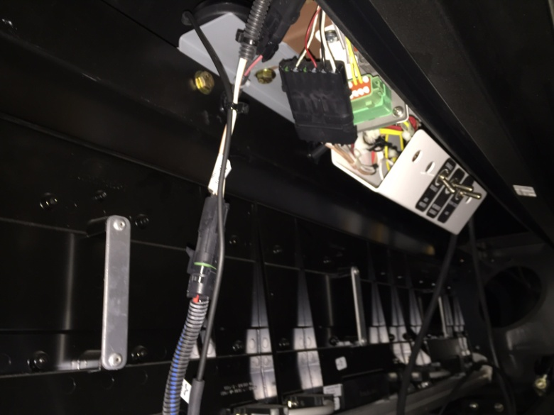
Figure 5. Inside of top panel of New Flyer bus with power lines

Setup of BusTracker
Before testing the BusTracker, an account must be setup with Telit. The chip that contains the GPS receiver and cellular connector is produced by Telit. Telit also maintains the deviceWise online server where information about connected BusTrackers and GPS data is stored. Transpo operators should contact Telit to register for a deviceWise account and AT&T connectivity data plan.
The BusTracker is programmed to automatically set itself up once it receives power. When a bus is turned on, power from the bus's 12V line will start up the BusTracker. The onboard LED of the BusTracker should start blinking once it is fully operating. The BusTracker will connect to the cellular network as start transmitting current GPS positions to the deviceWise server. The process will take, at most, two minutes. There is no setup required on the driver's side.
To download the Bus Tracker app, XCode must be installed on a Mac computer. Download the code from the Box folder and run the app on a connected iPhone.

Verify Operation of BusTracker
Operation of the BusTracker can be verified by two different methods. Transpo operators can login to the deviceWISE server and observe the locations of entire bus fleet that is currently running. Bus riders can also download the BusTracker app and see the current location of the bus in question.

Troubleshooting

Troubleshooting BusTracker Box
- If the BusTracker system no longer updates the location of the bus, check the BusTracker box to verify that the LED is blinking, which signifies the tracking module being correctly turned on.
- Check all antenna connectors to verify that neither the cellular nor GPS antenna has come unconnected. If the location of the bus does not seem to be changing, check the mounting location of the GPS antenna as it may have lost its satellite fix.
- If the board does not seem to be powering on at all verify that the Telit miniPCIe adapter on the board has not come loose from its connector.
- Verify that the BusTracker has not accidently been connected to the 24V power line.

Troubleshooting BusTracker App
- If the current bus location does not seem to be changing, try switching back and forth between your current stop in order to refresh the bus location.
- Close and restart the app in case of crashes.

Customer Support
For BusTracker box hardware issues, contact Christine Joseph at cjoseph1@nd.edu or Grant Weber at gweber2@nd.edu
For Telit account and connectivity questions, contact Grant Weber at gweber2@nd.edu
For questions regarding the BusTracker app download and code, contact SeungGoo Kang at skang2@nd.edu or Racine Hansen at rhansen3@nd.edu

Appendix B: Microcontroller Code to Setup UARTs and Send and Parse GPS AT Commands

/*
* File: main.c
*/

#include <xc.h>
#include "configbits-16ex8.h"
#include "string.h"

#define u2_buff_full U2STAbits.UTXBF
#define u2_buff_fullRX U2STAbits.URXDA
#define u1_buff_fullRX U1STAbits.URXDA
#define GetSystemClock() (40000000ul)
#define GetPeripheralClock() (GetSystemClock())

#define BUFMAX 128

char gps_string[BUFMAX];
float lat, lon, lat1, lon1;
int fix, qual, dd;
char *start_ptr, *end_ptr, *latitude, *longitude, *quality;

//initialize UART1
void serial_init1(unsigned long rate) //rate = desired baud rate
{
U2MODEbits.ON = 1; //enable UART1
U2MODEbits.BRGH = 1; //baud rate
U2MODEbits.UEN = 0b00; //enable bits
U2MODEbits.PDSEL = 0b00; //8 bit no parity
U2MODEbits.STSEL = 0; //1 stop bit

U2STAbits.URXEN = 1; //enable receiver
U2STAbits.UTXEN = 1; //enable transmitter

U2BRG = ((GetSystemClock())/(4*rate))-1;
return;
}

//initialize UART2
void serial_init2(unsigned long rate) //rate = desired baud rate
{
U1MODEbits.ON = 1; //enable UART1
U1MODEbits.BRGH = 1; //baud rate
U1MODEbits.UEN = 0b00; //enable bits
U1MODEbits.PDSEL = 0b00; //8 bit no parity
U1MODEbits.STSEL = 0; //1 stop bit

U1STAbits.URXEN = 1; //enable receiver
U1STAbits.UTXEN = 1; //enable transmitter

U1BRG = ((GetSystemClock())/(4*rate))-1;
return;
}

void setup_pps(void) {
SYSKEY = 0x0;
SYSKEY = 0xAA996655;
SYSKEY = 0x556699AA;

CFGCONbits.IOLOCK = 0;
U2RXRbits.U2RXR = 0; //pin 3 rpa1
RPA3Rbits.RPA3R = 2; //pin 10 rpa3

U1RXRbits.U1RXR = 2; //pin12 rpa4
RPB4Rbits.RPB4R = 1; //pin 11 rpb4

CFGCONbits.IOLOCK = 1;
SYSKEY = 0x0;
}

//transmit function for UART1
int SerialTransmitU1(const char *buffer)
{
unsigned int size = strlen(buffer);
while( size)
{
while( U1STAbits.UTXBF); // wait while TX buffer full
U1TXREG = *buffer; // send single character to transmit buffer

buffer++; // transmit next character on following loop
size--; // loop until all characters sent (when size = 0)
}

while( !U1STAbits.TRMT); // wait for last transmission to finish

return 0;
}

//transmit function for UART2
int SerialTransmitU2(const char *buffer)
{
unsigned int size = strlen(buffer);
while( size)
{
while( U2STAbits.UTXBF); // wait while TX buffer full
U2TXREG = *buffer; // send single character to transmit buffer

buffer++; // transmit next character on following loop
size--; // loop until all characters sent (when size = 0)
}

while( !U2STAbits.TRMT); // wait for last transmission to finish

return 0;
}

//receive function for UART2
unsigned int SerialReceiveU2(char *buffer, unsigned int max_size)
{
unsigned int num_char = 0;

/* Wait for and store incoming data until either a carriage return is received
* or the number of received characters (num_chars) exceeds max_size */
while(num_char < max_size)
{
while( !U2STAbits.URXDA); // wait until data available in RX buffer
*buffer = U2RXREG; // empty contents of RX buffer into *buffer pointer

// insert nul character to indicate end of string
if( *buffer == '\r'){
*buffer = '\0';
break;
}

buffer++;
num_char++;
}

return num_char;
} // END SerialReceive()

//receive function for UART1
unsigned int SerialReceiveU1(char *buffer, unsigned int max_size)
{
unsigned int num_char = 0;

/* Wait for and store incoming data until either a carriage return is received
* or the number of received characters (num_chars) exceeds max_size */
while(num_char < max_size)
{
while( !U1STAbits.URXDA); // wait until data available in RX buffer
*buffer = U1RXREG; // empty contents of RX buffer into *buffer pointer

// insert nul character to indicate end of string
if( *buffer == '\r'){
*buffer = '\0';
break;
}

buffer++;
num_char++;
}

return num_char;
} // END SerialReceive()

//custom delay function
void myDelay(int delay){
//delay of 1 second = 3200000
unsigned int count;
for( count = 0; count < delay; count++) {}
}

void putu1(unsigned char val) // put char
{
_mon_putc(val);
return;
}

void myprintf(char S[]){
int length, i;
length = strlen(S);

for(i=0;i<length;i++){
putu1(S[i]);
}
}

//AT commands to start getting GPS data
void initalizeGPS(){
myprintf("AT\t");
myDelay(32000);
myprintf("AT$GPSRST\t");
myDelay(32000);
myprintf("AT$GPSNVRAM=15,0\t");
myDelay(32000);
myprintf("AT$GPSACP\t");
myDelay(32000);
}

void getGPSstr(){
char letter = SerialReceiveU1();
int i = 1;
while(letter != '$'){
letter = SerialReceiveU1();
}
gps_string[0] = letter;
while(letter != '*'){
letter = SerialReceiveU1();
gps_string[i] = letter;
i++;
}
}

//function to parse NMEA sentence
void parse(volatile unsigned char *string)
{
printf("%s\n", gps_string);

// LATITUDE
start_ptr=strchr(gps_string,','); //find start of time field
start_ptr=strchr(start_ptr+1,','); //find start of latitude field
latitude = start_ptr+1; //find first character in latitude field
printf ("Latitude starts at gps_string[%d]\n",latitude-gps_string);
end_ptr=strchr(latitude,','); //find end of latitude field
printf ("Latitude ends at gps_string[%d]\n",end_ptr-gps_string-1);
if (latitude-gps_string>=end_ptr-gps_string) //determine if latitude exists
{printf("Latitude not received\n");}
else
{
lat=atof(latitude); //convert to float
printf("Latitude = %f\n",lat);
}
// LATITUDE

// LONGITUDE
start_ptr=strchr(start_ptr+1,',');
start_ptr=strchr(start_ptr+1,',');
longitude = start_ptr+1;
printf ("Longitude starts at gps_string[%d]\n",longitude-gps_string);
end_ptr=strchr(longitude,',');
printf ("Longitude ends at gps_string[%d]\n",end_ptr-gps_string-1);
if (longitude-gps_string>=end_ptr-gps_string)
{printf("Longitude not received\n");}
else
{
lon=atof(longitude);
printf("Longitude = %f\n",lon);
}
// LONGITUDE

// QUALITY
start_ptr=strchr(start_ptr+1,',');
start_ptr=strchr(start_ptr+1,',');
quality = start_ptr+1;
printf ("Quality starts at gps_string[%d]\n",quality-gps_string);
end_ptr=strchr(quality,',');
printf ("Quality ends at gps_string[%d]\n",end_ptr-gps_string-1);
if (quality-gps_string>=end_ptr-gps_string)
{
printf("Quality not received\n");
fix = 0;
//RB1=0;
}
else
{
qual=atoi(quality);
printf("Quality = %d\n",qual);
if (qual==1|qual==2){
printf("Fix acquired\n");
fix = 1; //if fix acquired, turn GPS LED on
//RB1=1;
}
else{
printf("Fix not aquired\n");
fix=0; //if fix not acquired, turn GPS LED off
//RB1=0;
}
}

}

/*
* Program to flash the LED's
*/
int main(int argc, char** argv)
{

//DEVCFG0bits.ICESEL = 1;
//OSCCONbits.FRCDIV = 5;
//OSCCONbits.COSC = 0b101;
//CFGCONbits.JTAGEN = 0;

TRISACLR = 0xFFFF;
TRISBCLR = 0xFFFF;
ANSELACLR = 0xFFFF;
ANSELBCLR = 0xFFFF;

TRISAbits.TRISA3 = 0; //tx output
TRISAbits.TRISA1 = 1; //rx input
TRISAbits.TRISA4 = 1; //rx1 input
TRISBbits.TRISB4 = 0; //tx1 output
TRISAbits.TRISA2 = 0;

setup_pps();
serial_init1(9600);
serial_init2(9600);

initalizeGPS();
//parse();
return (EXIT_SUCCESS);
}

Appendix C: Mobile App View Controller Code

import UIKit
import CoreLocation
import PXGoogleDirections
import GoogleMaps
import CocoaMQTT

var originField = CLLocationCoordinate2D(latitude:41.669419,longitude:-86.250977)
var destinationField = CLLocationCoordinate2D(latitude: 41.659131, longitude: -86.180606)

var destinationScroll = 0
var date = NSDate()
var formatter = NSDateFormatter()

var fromLatitude:Double = 0
var fromLongitude:Double = 0

var toLatitude:Double = 0
var toLongitude:Double = 0

/*****************************************

MAIN VIEW CONTROLLER
- not used
- Seung Goo disabled in storyboard

*****************************************/

class MainViewController: UIViewController, CLLocationManagerDelegate, UIPickerViewDelegate{

var startArriveDate: NSDate?
var waypoints: [PXLocation] = [PXLocation]()
var mqtt: CocoaMQTT?
// var originField = CLLocationCoordinate2D(latitude:41.669419,longitude:-86.250977)

override func viewDidAppear(animated: Bool) {
super.viewDidAppear(animated)

directionsAPI.delegate = self
directionsAPI.from = PXLocation.CoordinateLocation(originField)
directionsAPI.to = PXLocation.CoordinateLocation(destinationField)
directionsAPI.mode = modeFromField()
directionsAPI.departureTime = .Now

// WaypointViewController()
calculateRoute()
}

private var directionsAPI: PXGoogleDirections {
return (UIApplication.sharedApplication().delegate as! AppDelegate).directionsAPI
}

private func modeFromField() -> PXGoogleDirectionsMode {
return PXGoogleDirectionsMode(rawValue: 0)!
}

private func WaypointViewController(){

let lat = 41.679211
let long = -86.235158
var waypoint: PXLocation?
waypoint = PXLocation.CoordinateLocation(CLLocationCoordinate2DMake(lat, long))
waypoints.append(waypoint!)

let lat2 = 41.680218
let long2 = -86.216060
var waypoint2: PXLocation?
waypoint2 = PXLocation.CoordinateLocation(CLLocationCoordinate2DMake(lat2, long2))
waypoints.append(waypoint2!)

let lat3 = 41.672990
let long3 = -86.196518
var waypoint3: PXLocation?
waypoint3 = PXLocation.CoordinateLocation(CLLocationCoordinate2DMake(lat3, long3))
waypoints.append(waypoint3!)

let lat4 = 41.659131
let long4 = -86.180606
var waypoint4: PXLocation?
waypoint4 = PXLocation.CoordinateLocation(CLLocationCoordinate2DMake(lat4, long4))
waypoints.append(waypoint4!)

directionsAPI.waypoints = waypoints
}

private func calculateRoute(){
directionsAPI.calculateDirections { (response) -> Void in
dispatch_async(dispatch_get_main_queue(), { () -> Void in
switch response {
case let .Error(_, error):
let alert = UIAlertController(title: "PXGoogleDirectionsSample", message: "Error: \(error.localizedDescription)", preferredStyle: UIAlertControllerStyle.Alert)
alert.addAction(UIAlertAction(title: "OK", style: .Default, handler: nil))
self.presentViewController(alert, animated: true, completion: nil)
case let .Success(request, routes):
if let rvc = self.storyboard?.instantiateViewControllerWithIdentifier("Results") as? ResultsViewController {
rvc.request = request
rvc.results = routes
self.presentViewController(rvc, animated: true, completion: nil)

}
}
})
}
}

}

var cnt:Double = 0
var cnt2:Int = 0

/*****************************************

RESULTS VIEW CONTROLLER

*****************************************/
class ResultsViewController: UIViewController, CLLocationManagerDelegate, GMSMapViewDelegate, UIPickerViewDelegate{

@IBOutlet weak var mqttTestLabel: UILabel!

@IBOutlet weak var pickerStop: UIPickerView!
@IBOutlet weak var routesLabel: UILabel!
@IBOutlet weak var mapView: GMSMapView!
@IBOutlet weak var directions: UITableView!
var request: PXGoogleDirections!
var results: [PXGoogleDirectionsRoute]!
var routeIndex: Int = 0
var waypoints: [PXLocation] = [PXLocation]()
var mqtt: CocoaMQTT?
//var originField = CLLocationCoordinate2D(latitude:41.669419,longitude:-86.250977)

@IBOutlet weak var arriveTime: UILabel!

private var directionsAPI: PXGoogleDirections {
return (UIApplication.sharedApplication().delegate as! AppDelegate).directionsAPI
}

private func modeFromField() -> PXGoogleDirectionsMode {
return PXGoogleDirectionsMode(rawValue: 0)!
}

//PICKER VIEW
var bstop = ["LaSelle & Eddy (Outbound)","McKinley & Ironwood (Outbound)","Jefferson & Logan (Outbound)","Mishawaka Transfer Center(Outbound)", "Jefferson & Logan (Inbound)","McKinley & Ironwood (Inbound)","LaSelle & Eddy (Inbound)"]

public func numberOfComponentsInPickerView(pickerView: UIPickerView) -> Int
{
return 1
}
func pickerView(pickerView: UIPickerView, numberOfRowsInComponent component: Int) -> Int
{
return bstop.count
}
func pickerView(pickerView: UIPickerView, titleForRow row: Int, forComponent component: Int) -> String?
{
return bstop[row]
}

func pickerView(pickerView: UIPickerView, didSelectRow row: Int, inComponent component: Int)
{
let calendar = NSCalendar.currentCalendar()
let components = calendar.components([.Hour, .Minute], fromDate: date)
let cHour = components.hour
let cMin = components.minute
var leftRight = 0
// Right = 1 , Left = 0
waypoints.removeAll()

if cHour >= 5 && cHour <= 21
{
if cMin >= 20 && cMin <= 44
{
leftRight = 1
}
if cMin > 44
{
leftRight = 0
}

}
if cHour >= 6 && cHour <= 22
{
if cMin <= 12
{
leftRight = 0
}

}
leftRight = 1

var zone = 0

if originField.longitude < -86.235250
{
zone = 1
}
if originField.longitude >= -86.235250 && originField.longitude < -86.216060
{
zone = 2
}
if originField.longitude >= -86.216060 && originField.longitude < -86.196518
{
zone = 3
}
if originField.longitude >= -86.196518
{
zone = 4
}

let lat = 41.679211
let long = -86.235158
var waypoint: PXLocation?
waypoint = PXLocation.CoordinateLocation(CLLocationCoordinate2DMake(lat, long))
// waypoints.append(waypoint!)

let lat2 = 41.680218
let long2 = -86.216060
var waypoint2: PXLocation?
waypoint2 = PXLocation.CoordinateLocation(CLLocationCoordinate2DMake(lat2, long2))
// waypoints.append(waypoint2!)

let lat3 = 41.672990
let long3 = -86.196518
var waypoint3: PXLocation?
waypoint3 = PXLocation.CoordinateLocation(CLLocationCoordinate2DMake(lat3, long3))
// waypoints.append(waypoint3!)

let lat4 = 41.659131
let long4 = -86.180606
var waypoint4: PXLocation?
waypoint4 = PXLocation.CoordinateLocation(CLLocationCoordinate2DMake(lat4, long4))
// waypoints.append(waypoint4!)

mapView.clear()

var bstopSelected = bstop[row]

if bstopSelected == "LaSelle & Eddy (Outbound)"{
destinationField = CLLocationCoordinate2DMake(41.679211, -86.235158)
destinationScroll = 0
}
if bstopSelected == "McKinley & Ironwood (Outbound)"{
destinationField = CLLocationCoordinate2DMake(41.680218,-86.216060)
destinationScroll = 1
if zone == 1 && leftRight == 1
{
waypoints.append(waypoint!)
}
}
if bstopSelected == "Jefferson & Logan (Outbound)"{
destinationField = CLLocationCoordinate2DMake(41.672990,-86.196518)
if zone == 1 && leftRight == 1
{
waypoints.append(waypoint!)
waypoints.append(waypoint2!)
}
if zone == 2 && leftRight == 1
{
waypoints.append(waypoint2!)
}

destinationScroll = 2
}
if bstopSelected == "Mishawaka Transfer Center(Outbound)"{
destinationField = CLLocationCoordinate2DMake(41.659131,-86.180606)
if zone == 1 && leftRight == 1
{
waypoints.append(waypoint!)
waypoints.append(waypoint2!)
waypoints.append(waypoint3!)
}
if zone == 2 && leftRight == 1
{
waypoints.append(waypoint2!)
waypoints.append(waypoint3!)
}
if zone == 3 && leftRight == 1
{

waypoints.append(waypoint3!)
}
destinationScroll = 3
}
if bstopSelected == "Jefferson & Logan (Inbound)"{
destinationField = CLLocationCoordinate2DMake(41.672990,-86.196518)
if zone == 1 && leftRight == 1
{
waypoints.append(waypoint!)
waypoints.append(waypoint2!)
waypoints.append(waypoint3!)
waypoints.append(waypoint4!)
}
if zone == 2 && leftRight == 1
{
waypoints.append(waypoint2!)
waypoints.append(waypoint3!)
waypoints.append(waypoint4!)
}
if zone == 3 && leftRight == 1
{

waypoints.append(waypoint3!)
waypoints.append(waypoint4!)
}
if zone == 4 && leftRight == 1
{
waypoints.append(waypoint4!)
}
destinationScroll = 4
}
if bstopSelected == "McKinley & Ironwood (Inbound)"{
destinationField = CLLocationCoordinate2DMake(41.680218,-86.216060)
if zone == 1 && leftRight == 1
{
waypoints.append(waypoint!)
waypoints.append(waypoint2!)
waypoints.append(waypoint3!)
waypoints.append(waypoint4!)
waypoints.append(waypoint3!)
}
if zone == 2 && leftRight == 1
{
waypoints.append(waypoint2!)
waypoints.append(waypoint3!)
waypoints.append(waypoint4!)
waypoints.append(waypoint3!)
}
if zone == 3 && leftRight == 1
{

waypoints.append(waypoint3!)
waypoints.append(waypoint4!)
waypoints.append(waypoint3!)
}
if zone == 4 && leftRight == 1
{
waypoints.append(waypoint4!)
waypoints.append(waypoint3!)
}
if zone == 4 && leftRight == 0
{
waypoints.append(waypoint3!)
}
destinationScroll = 5
}
if bstopSelected == "LaSelle & Eddy (Inbound)"{
destinationField = CLLocationCoordinate2DMake(41.679211, -86.235158)
if zone == 1 && leftRight == 1
{
waypoints.append(waypoint!)
waypoints.append(waypoint2!)
waypoints.append(waypoint3!)
waypoints.append(waypoint4!)
waypoints.append(waypoint3!)
waypoints.append(waypoint2!)
}
if zone == 2 && leftRight == 1
{
waypoints.append(waypoint2!)
waypoints.append(waypoint3!)
waypoints.append(waypoint4!)
waypoints.append(waypoint3!)
waypoints.append(waypoint2!)
}
if zone == 3 && leftRight == 1
{

waypoints.append(waypoint3!)
waypoints.append(waypoint4!)
waypoints.append(waypoint3!)
waypoints.append(waypoint2!)
}
if zone == 4 && leftRight == 1
{
waypoints.append(waypoint4!)
waypoints.append(waypoint3!)
waypoints.append(waypoint2!)
}
if zone == 4 && leftRight == 0
{

waypoints.append(waypoint3!)
waypoints.append(waypoint2!)
}
if zone == 3 && leftRight == 0
{
waypoints.append(waypoint2!)
}

destinationScroll = 6
}

mqttSetting()

directionsAPI.from = PXLocation.CoordinateLocation(originField)
directionsAPI.to = PXLocation.CoordinateLocation(destinationField)
directionsAPI.mode = modeFromField()
directionsAPI.departureTime = .Now
directionsAPI.waypoints = waypoints
// mqttTestLabel.text = String(originField.latitude)
date = NSDate()
let marker = GMSMarker()
marker.position = originField
marker.title = "Bus"
marker.map = mapView
marker.icon = UIImage(named:"bus.png")

stopMark()
//
// viewDidLoad()
calculateRoute()
updateRoute()
}

override func viewDidLoad() {
super.viewDidLoad()
mqttSetting()
mapView.delegate = self
// directionsAPI.delegate = self
directionsAPI.from = PXLocation.CoordinateLocation(originField)
directionsAPI.to = PXLocation.CoordinateLocation(destinationField)
directionsAPI.mode = modeFromField()
directionsAPI.departureTime = .Now
// directionsAPI.waypoints = waypoints

pickerStop.selectRow(destinationScroll, inComponent: 0, animated: true)

let marker = GMSMarker()
marker.position = originField
marker.title = "Bus"
marker.map = mapView
marker.icon = UIImage(named:"bus.png")

stopMark()

}

func stopMark(){
//Stop1

let marker1 = GMSMarker()
marker1.position = CLLocationCoordinate2DMake(41.669419, -86.250977)
marker1.title = "South Bend Station"
marker1.map = mapView

//Stop2
let marker2 = GMSMarker()
marker2.position = CLLocationCoordinate2DMake(41.679211, -86.235158)
marker2.title = "LaSelle & Eddy"
marker2.map = mapView

//Stop3
let marker3 = GMSMarker()
marker3.position = CLLocationCoordinate2DMake(41.680218,-86.216060)
marker3.title = "McKinley & Ironwood"
marker3.map = mapView

//Stop4
let marker4 = GMSMarker()
marker4.position = CLLocationCoordinate2DMake(41.672990,-86.196518)
marker4.title = "Jefferson & Logan"
marker4.map = mapView

//Stop5
let marker5 = GMSMarker()
marker5.position = CLLocationCoordinate2DMake(41.659131,-86.180606)
marker5.title = "Mishawaka Transfer Center"
marker5.map = mapView
}

private func WaypointViewController(){

let lat = 41.679211
let long = -86.235158
var waypoint: PXLocation?
waypoint = PXLocation.CoordinateLocation(CLLocationCoordinate2DMake(lat, long))
waypoints.append(waypoint!)

let lat2 = 41.687114
let long2 = -86.238023
var waypoint2: PXLocation?
waypoint2 = PXLocation.CoordinateLocation(CLLocationCoordinate2DMake(lat2, long2))
waypoints.append(waypoint2!)

let lat3 = 41.694414
let long3 = -86.226490
var waypoint3: PXLocation?
waypoint3 = PXLocation.CoordinateLocation(CLLocationCoordinate2DMake(lat3, long3))
waypoints.append(waypoint3!)

let lat4 = 41.702451
let long4 = -86.232815
var waypoint4: PXLocation?
waypoint4 = PXLocation.CoordinateLocation(CLLocationCoordinate2DMake(lat4, long4))
waypoints.append(waypoint4!)

let lat5 = 41.699957
let long5 = -86.216555
var waypoint5: PXLocation?
waypoint5 = PXLocation.CoordinateLocation(CLLocationCoordinate2DMake(lat5, long5))
var waypointSSS: PXLocation?
waypointSSS = PXLocation.CoordinateLocation(CLLocationCoordinate2DMake(41.669419, -86.250977))
waypoints.append(waypoint5!)
waypoints.append(waypoint4!)
waypoints.append(waypoint3!)
waypoints.append(waypoint2!)
waypoints.append(waypoint!)
waypoints.append(waypointSSS!)

directionsAPI.waypoints = waypoints
}

private func calculateRoute(){
directionsAPI.calculateDirections { (response) -> Void in
dispatch_async(dispatch_get_main_queue(), { () -> Void in
switch response {
case let .Error(_, error):
let alert = UIAlertController(title: "PXGoogleDirectionsSample", message: "Error: \(error.localizedDescription)", preferredStyle: UIAlertControllerStyle.Alert)
alert.addAction(UIAlertAction(title: "OK", style: .Default, handler: nil))
self.presentViewController(alert, animated: true, completion: nil)
case let .Success(request, routes):
if let rvc = self.storyboard?.instantiateViewControllerWithIdentifier("Results") as? ResultsViewController {
rvc.request = request
rvc.results = routes
self.presentViewController(rvc, animated: true, completion: nil)
}
}
})
}
}

override func viewWillAppear(animated: Bool) {
super.viewWillAppear(animated)
updateRoute()
}

func updateRoute() {
for i in 0 ..< (results).count {
if i != routeIndex {
results[i].drawOnMap(mapView, strokeColor: UIColor.lightGrayColor(), strokeWidth: 3.0)
}
}
mapView.animateWithCameraUpdate(GMSCameraUpdate.fitBounds(results[routeIndex].bounds, withPadding: -10.0))

results[routeIndex].drawOnMap(mapView, strokeColor: UIColor.purpleColor(), strokeWidth: 4.0)
results[routeIndex].drawOriginMarkerOnMap(mapView, title: "Origin", color: UIColor.greenColor(), opacity: 1.0, flat: true)
results[routeIndex].drawDestinationMarkerOnMap(mapView, title: "Destination", color: UIColor.redColor(), opacity: 1.0, flat: true)
directions.reloadData()
}

func mqttSetting() {
let clientIdPid = "CocoaMQTT-" + String(NSProcessInfo().processIdentifier)
mqtt = CocoaMQTT(clientId: clientIdPid, host: "api.devicewise.com", port: 1883)
//mqtts
//let mqtt = CocoaMQTT(clientId: clientIdPid, host: "localhost", port: 8883)
//mqtt.secureMQTT = true
if let mqtt = mqtt {
mqtt.username = "gweber2@nd.edu"
mqtt.password = "BusTracker2016!"
//mqtt.willMessage = CocoaMQTTWill(topic: "/will", message: "dieout")
mqtt.keepAlive = 60
mqtt.delegate = self
mqtt.connect()
//mqtt.subscribe("thing/357164040554068/property/latitude")
//dispatch_main()
//originField = CLLocationCoordinate2D(latitude:41.679419,longitude:-86.260977)
}
}
}

/*****************************************

EXTENSIONS

*****************************************/
extension ResultsViewController:UITableViewDataSource{
func numberOfSectionsInTableView(tableView: UITableView) -> Int {
return (results[routeIndex].legs).count
}

func tableView(tableView: UITableView, numberOfRowsInSection section: Int) -> Int {
return (results[routeIndex].legs[section].steps).count
}

func tableView(tableView: UITableView, titleForHeaderInSection section: Int) -> String? {
let leg = results[routeIndex].legs[section]
formatter.dateFormat = "hh:mm a"

if let dist = leg.distance?.description, dur = leg.duration?.description, durr = leg.duration?.duration {

let abs = Double(durr)

// print(section)
let defaultTime = formatter.stringFromDate(date);
formatter.dateFormat = "hh:mm a"
var arrtime = date
var addDuration = [Double](count:15, repeatedValue: 0.0)
var totalDuration:Double
totalDuration = 0

// print(results[routeIndex].legs[0].endLocation)
// fromLatitude = (results[routeIndex].legs[0].endLocation?.latitude)!
// fromLongitude = (results[routeIndex].legs[0].endLocation?.longitude)!
// var tmp = results[routeIndex].legs.count-1
//
// toLatitude = (results[routeIndex].legs[tmp].endLocation?.latitude)!
// toLongitude = (results[routeIndex].legs[tmp].endLocation?.longitude)!
//
for var n=0;n<=results[routeIndex].legs.count-1;++n
{
addDuration[n+1] = Double((results[routeIndex].legs[n].duration?.duration)!)
//arrtime = date.dateByAddingTimeInterval(Double((results[routeIndex].legs[n].duration?.duration)!))

}
for var n=0;n<=results[routeIndex].legs.count-1;++n
{
totalDuration = totalDuration + addDuration[n+1]
//arrtime = date.dateByAddingTimeInterval(Double((results[routeIndex].legs[n].duration?.duration)!))

}
arrtime = date.dateByAddingTimeInterval(totalDuration)

let aTime = formatter.stringFromDate(arrtime);
arriveTime.text = aTime

return "Stop \(section + 1) (\(dist), \(dur))"

} else {
return "Stop \(section + 1)"
}
}

func tableView(tableView: UITableView, cellForRowAtIndexPath indexPath: NSIndexPath) -> UITableViewCell {
var cell = tableView.dequeueReusableCellWithIdentifier("RouteStep")
if (cell == nil) {
cell = UITableViewCell(style: .Subtitle, reuseIdentifier: "RouteStep")
}

let step = results[routeIndex].legs[indexPath.section].steps[indexPath.row]

print(results[routeIndex].legs[0].steps[0].endLocation)

if let instr = step.rawInstructions {
cell!.textLabel!.text = instr
}
if let dist = step.distance?.description, dur = step.duration?.description {
cell!.detailTextLabel?.text = "\(dist), \(dur)"
}
return cell!

}
}

extension ResultsViewController: CocoaMQTTDelegate {
func mqtt(mqtt: CocoaMQTT, didConnect host: String, port: Int) {
print("didConnect \(host):\(port)")
}

func mqtt(mqtt: CocoaMQTT, didConnectAck ack: CocoaMQTTConnAck) {
//print("didConnectAck \(ack.rawValue)")
if ack == .ACCEPT {
mqtt.subscribe("thing/357164040554068/property/latitude", qos: CocoaMQTTQOS.QOS0)
mqtt.subscribe("thing/357164040554068/property/longitude", qos: CocoaMQTTQOS.QOS0)
mqtt.ping()
}
}

func mqtt(mqtt: CocoaMQTT, didPublishMessage message: CocoaMQTTMessage, id: UInt16) {
print("didPublishMessage with message: \(message.string)")
}

func mqtt(mqtt: CocoaMQTT, didPublishAck id: UInt16) {
print("didPublishAck with id: \(id)")
}

func mqtt(mqtt: CocoaMQTT, didReceiveMessage message: CocoaMQTTMessage, id: UInt16 ) {
print("didReceivedMessage: \(message.string) with id \(message.topic)")

if (message.topic == "thing/357164040554068/property/latitude"){
// mqttTestLabel.text = message.string
let originDoubleLat:Double = Double(message.string!)!
originField.latitude = originDoubleLat
}
if (message.topic == "thing/357164040554068/property/longitude"){
let originDoubleLong:Double = Double(message.string!)!
originField.longitude = originDoubleLong
}

}

func mqtt(mqtt: CocoaMQTT, didSubscribeTopic topic: String) {
print("didSubscribeTopic to \(topic)")
}

func mqtt(mqtt: CocoaMQTT, didUnsubscribeTopic topic: String) {
print("didUnsubscribeTopic to \(topic)")
}

func mqttDidPing(mqtt: CocoaMQTT) {
print("didPing")
}

func mqttDidReceivePong(mqtt: CocoaMQTT) {
_console("didReceivePong")
}

func mqttDidDisconnect(mqtt: CocoaMQTT, withError err: NSError?) {
_console("mqttDidDisconnect")
}

func _console(info: String) {
print("Delegate: \(info)")
}
}

extension ResultsViewController: UITableViewDelegate {
}

extension MainViewController: PXGoogleDirectionsDelegate {
func googleDirectionsWillSendRequestToAPI(googleDirections: PXGoogleDirections, withURL requestURL: NSURL) -> Bool {
NSLog("googleDirectionsWillSendRequestToAPI:withURL:")
return true
}

func googleDirectionsDidSendRequestToAPI(googleDirections: PXGoogleDirections, withURL requestURL: NSURL) {
NSLog("googleDirectionsDidSendRequestToAPI:withURL:")
NSLog("\(requestURL.absoluteString.stringByAddingPercentEncodingWithAllowedCharacters(NSCharacterSet.URLQueryAllowedCharacterSet())!)")
}

func googleDirections(googleDirections: PXGoogleDirections, didReceiveRawDataFromAPI data: NSData) {
NSLog("googleDirections:didReceiveRawDataFromAPI:")
NSLog(NSString(data: data, encoding: NSUTF8StringEncoding) as! String)
}

func googleDirectionsRequestDidFail(googleDirections: PXGoogleDirections, withError error: NSError) {
NSLog("googleDirectionsRequestDidFail:withError:")
NSLog("\(error)")
}

func googleDirections(googleDirections: PXGoogleDirections, didReceiveResponseFromAPI apiResponse: [PXGoogleDirectionsRoute]) {
NSLog("googleDirections:didReceiveResponseFromAPI:")
NSLog("Got \(apiResponse.count) routes")
for i in 0 ..< apiResponse.count {
NSLog("Route \(i) has \(apiResponse[i].legs.count) legs")
}
}
}

Appendix D: Final Board Schematics
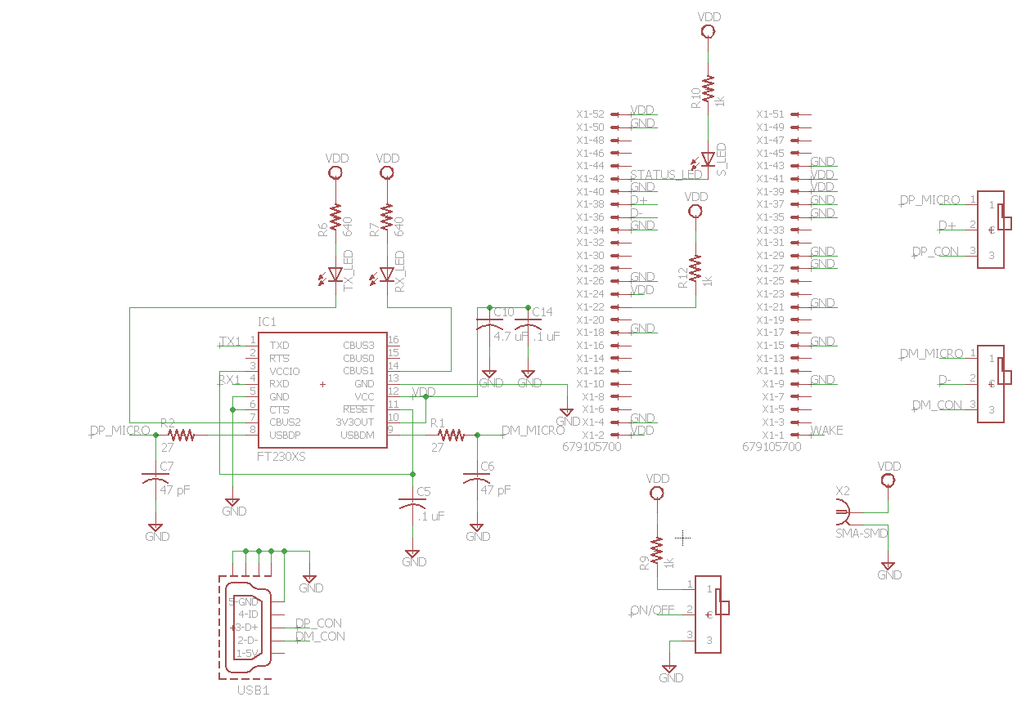
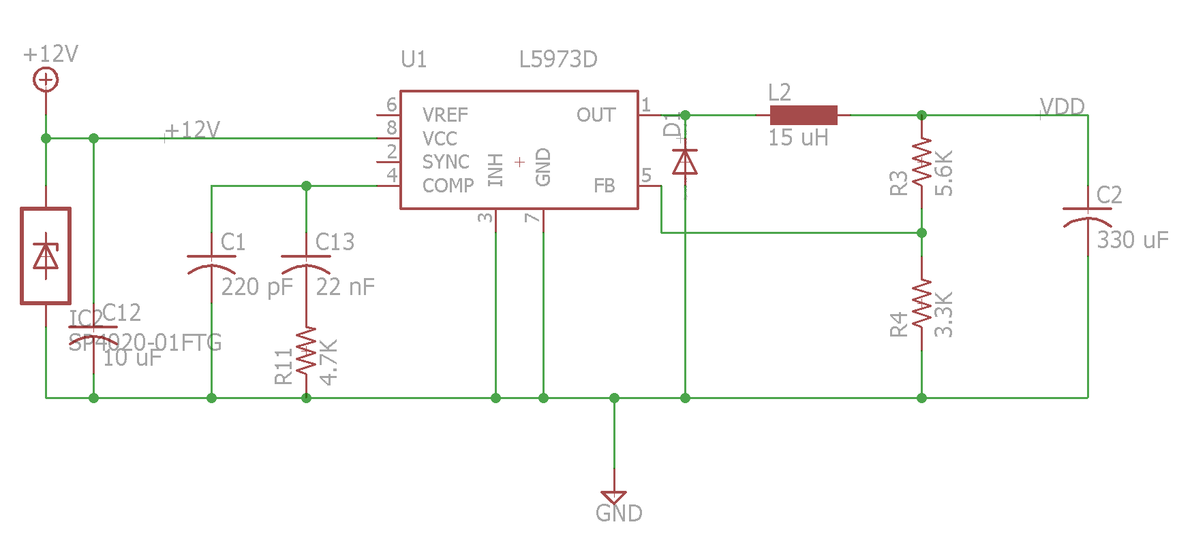
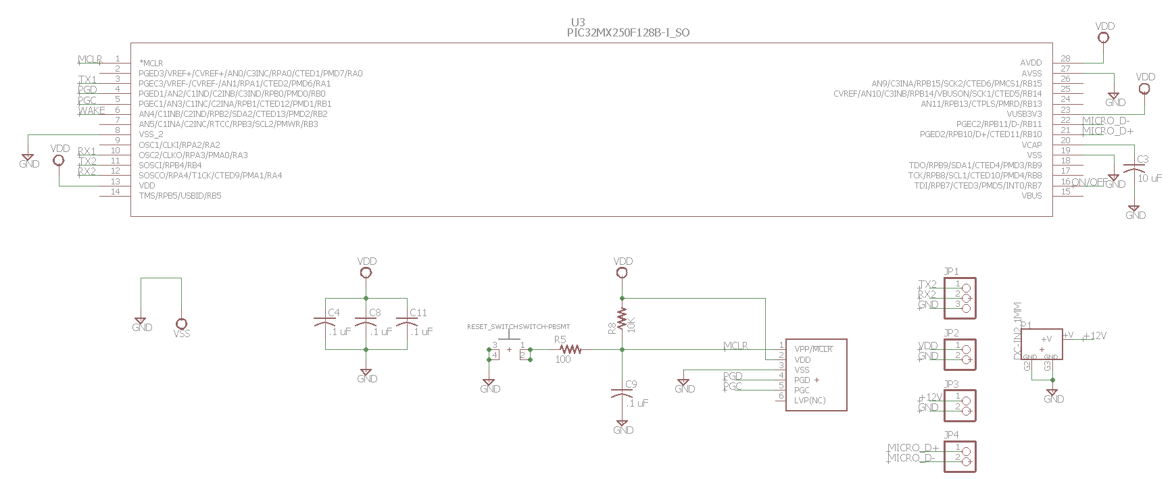

Appendix E: Final Board
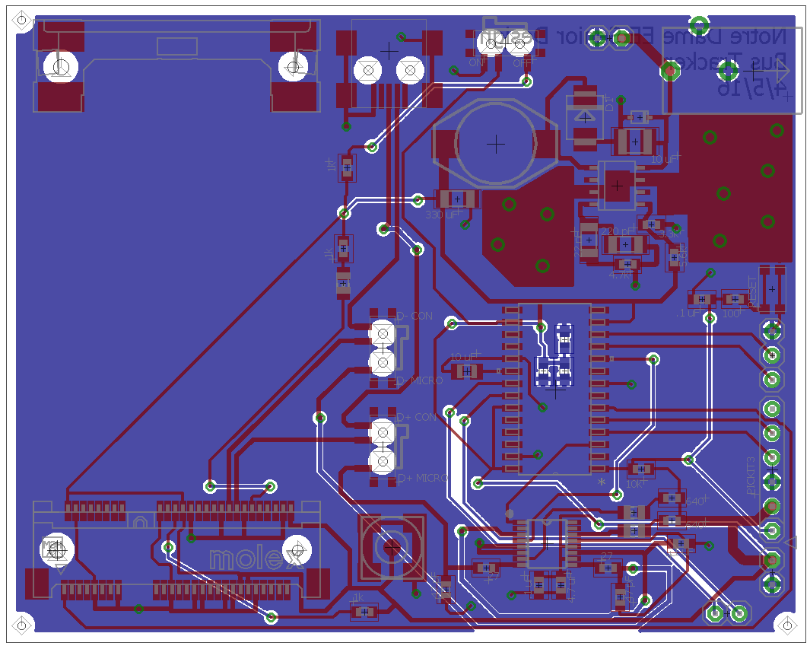

Appendix F: Relevant Data Sheets and Hardware Guides:

PIC32MX250F128B Datasheet:
http://ww1.microchip.com/downloads/en/DeviceDoc/60001168J.pdf

FT230XS Datasheet:
http://www.ftdichip.com/Support/Documents/DataSheets/ICs/DS_FT230X.pdf

Telit HE910 Mini PCIE Hardware Guide:
http://www.telit.com/fileadmin/user_upload/products/Downloads/Telit_xE910_Mini_PCIe_Adapter_Hardware_User_Guide_r10.pdf

Telit AT Commands Reference Guide:
http://www.janus-rc.com/Documentation/Telit_HE910_AT_Commands_Reference_Guide_r5.pdf

Telit HE910 Hardware Guide:
http://www.telit.com/fileadmin/user_upload/products/Downloads/3G/xe910/Telit_HE910_Hardware_User_Guide_r27.pdf

Mini-Circuits Bias Tee Datasheet:
http://www.minicircuits.com/pdfs/ZFBT-4R2G+.pdf

Appendix G: Build of Materials for PCB

Qty | Value | Device | Package | Parts | Description
3 |  | LEDCHIP-LED0805 | CHIP-LED0805 | RX_LED, S_LED, TX_LED | LED
3 |  | PINHD-1X2S | 1X02N | JP2, JP3, JP4 | PIN HEADER
1 |  | PINHD-1X3 | 1X03N | JP1 | PIN HEADER
1 |  | USB-MINI-MICRO-BMINI | USB-MINI-FCI10033527 | USB1
6 | .1 uF | C-USC0603 | C0603 | C4, C5, C8, C9, C11, C14 | CAPACITOR, American symbol
1 | 10 uF | C-USC0805K | C0805K | C3 | CAPACITOR, American symbol
1 | 10 uF | GRM32DR61E106KA12L | C1210 | C12 | CAPACITOR, American symbol, Voltage regulator part
1 | 100 | R-US_R0603 | R0603 | R5 | RESISTOR, American symbol
1 | 10K | R-US_R0603 | R0603 | R8 | RESISTOR, American symbol
1 | 15 uH | DO3316P | DO3316P | L2 | COILCRAFT
3 | 1k | R-US_R0603 | R0603 | R9, R10, R12 | RESISTOR, American symbol
1 | 22 nF | C-USC1206C223K5RAC | C1206 | C13 | CAPACITOR, American symbol, Voltage regulator part
1 | 220 pF | C-USC1206C221J5GAC | C1206 | C1 | CAPACITOR, American symbol
2 | 27 | R-US_R0603 | R0603 | R1, R2 | RESISTOR, American symbol
1 | 3.3K | R-US_R0603 | R0603 | R4 | RESISTOR, American symbol
1 | 330 uF | POSCAP 6TPB330M | C3216 | C2 | CAPACITOR, American symbol
1 | 4.7 uF | C-USC0603 | C0603 | C10 | CAPACITOR, American symbol
1 | 4.7K | R-US_R0603 | R0603 | R11 | RESISTOR, American symbol
2 | 47 pF | C-USC0603 | C0603 | C6, C7 | CAPACITOR, American symbol
1 | 5.6K | R-US_R0603 | R0603 | R3 | RESISTOR, American symbol
2 | 270 | R-US_R0603 | R0603 | R6, R7 | RESISTOR, American symbol
1 | 679105700 | 679105700 | 679105700 | X1 | MINI PCI EXPRESS CONNECTOR 0.8MM PITCH, 52 CIRCUIT
1 | DC-IN2.1MM | DC-IN2.1MM | DC-POWERJACK | P1
1 | ES2D | STPS2L25U | SMB | D1 | DIODE, Need 2A protection
1 | FT230XS | FT230XS | SSOP16 | IC1 | USB to BASIC UART IC
1 | L5973D | L5973D | HSOP8 | U1 | 2.5A switch step down switching regulator
1 | PIC32MX250F128B-I_SO | PIC32MX250F128B-I_SO | SOIC28-W_MC | U3
1 | PICKIT3 | PICKIT3 | PICKIT3 | U$1
3 | SLIDE-SPDTCUS12B | SLIDE-SPDTCUS12B | CUS12B | U$5, U$6, U$7
1 | SMA-SMD | SMA-SMD | SMA-SMD | X2 | SMA 50 Ohm Straight Jack Receptacle - Surface Mount
1 | SP4020-01FTG | SP4020-01FTG | SOD323 | IC2 | SP4020 Series 2.5pF, 30A Discrete TVS Diode
1 | SWITCH-PBSMT | SWITCH-PBSMT | SMTPBSW | RESET_SWITCH

